**Assignment 5**

**Problem Statement:**

You work for a corporation that uses on premise solutions and some limited number of systems. With the increase in requests in their application, the load also increases. So, to handle the load the corporation has to buy more systems almost on a regular basis. Realizing the need to cut down the expenses on systems, they decided to move their infrastructure to AWS.

**Tasks To Be Performed:**

1. Create a web server AMI with Apache 2 server running in it.

2. Create a launch configuration with this AMI.

3. Use this launch configuration to create an Auto Scaling group with 1 minimum and 3 maximum instances.

**Solution:**

Step 1:- Create an EC2 & from it create an image

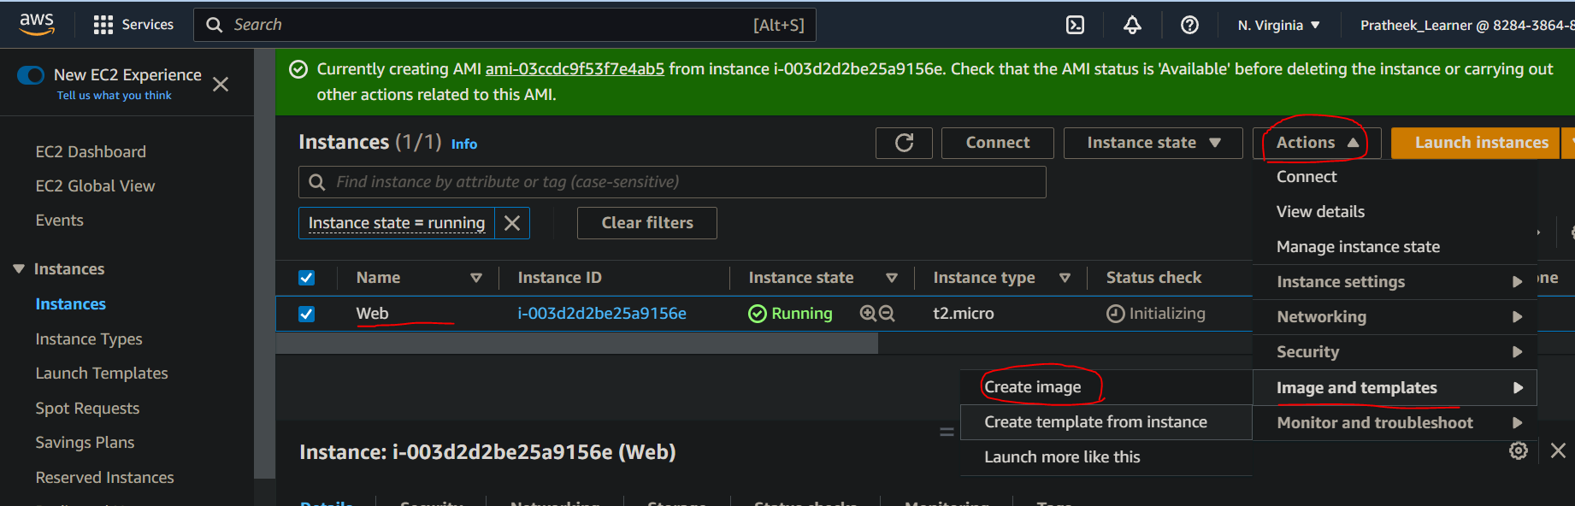

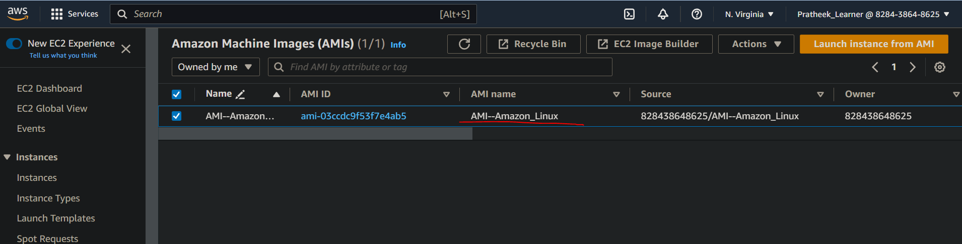

Step 2:- Select Launch configuration from ASG group options

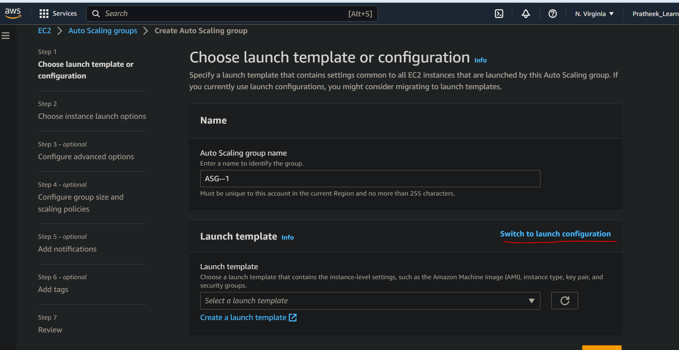

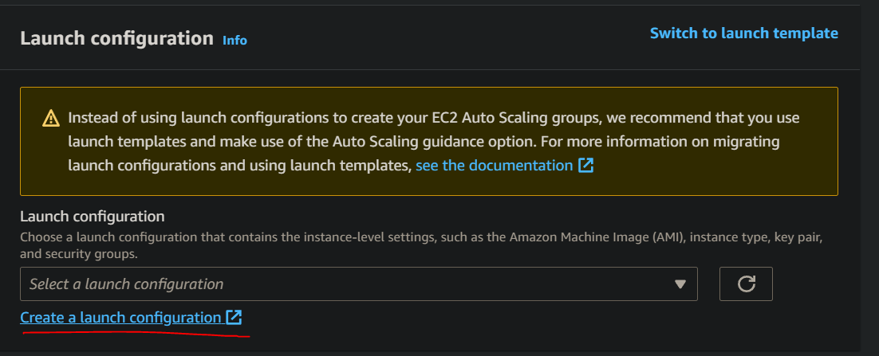

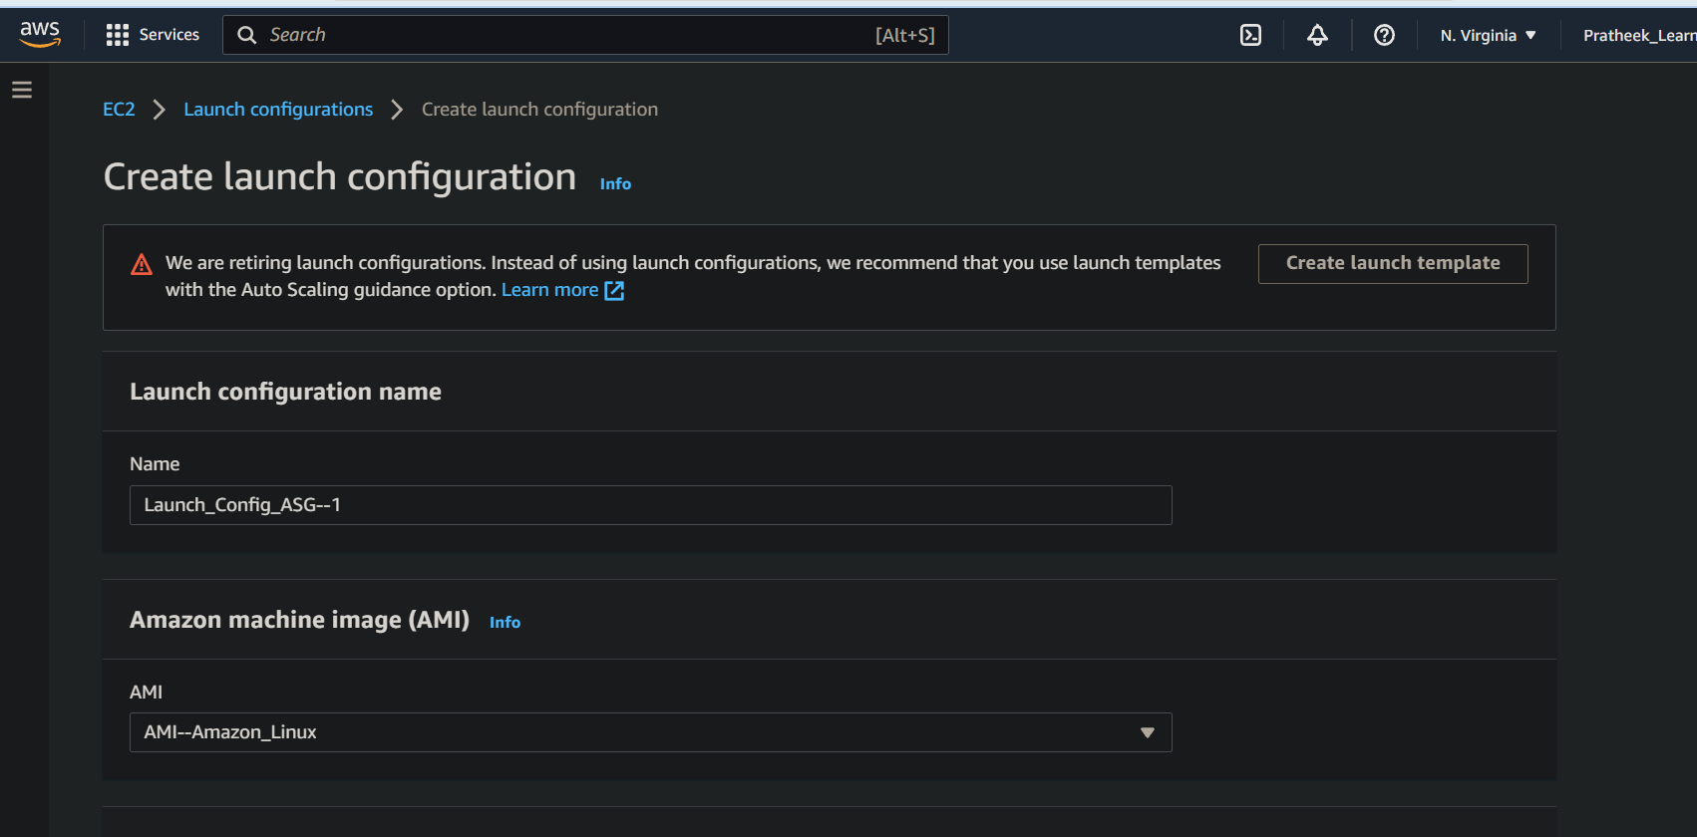

Launch Config created

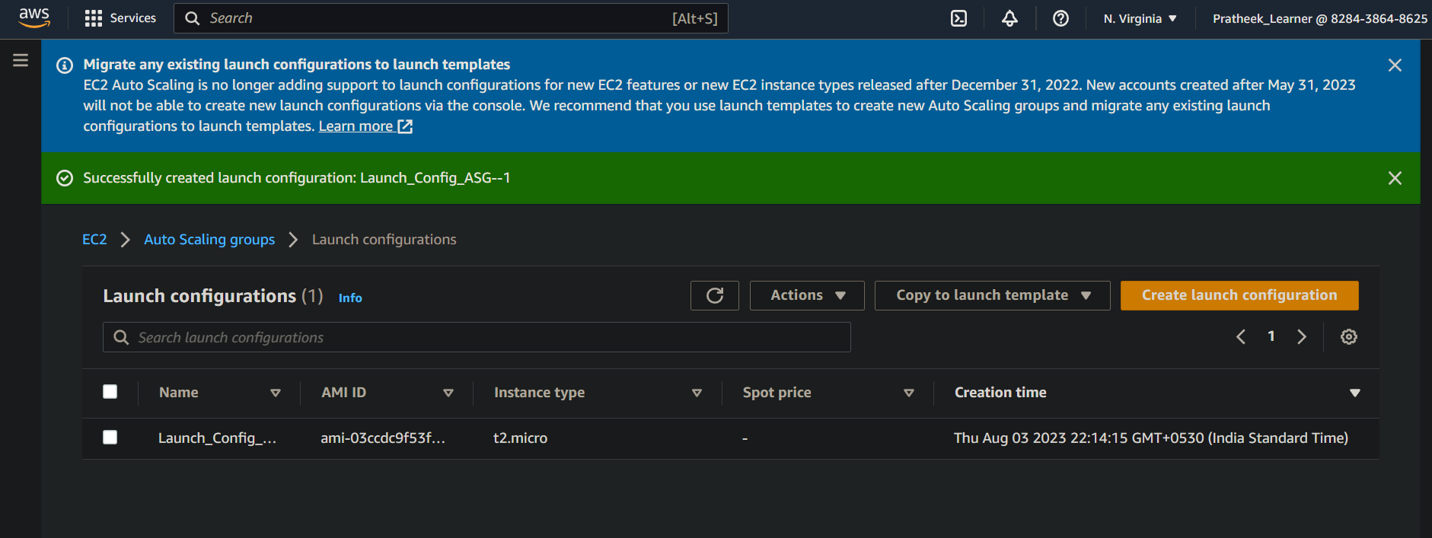

Step 3:- Configuring ASG with min & max instance values & other stuff

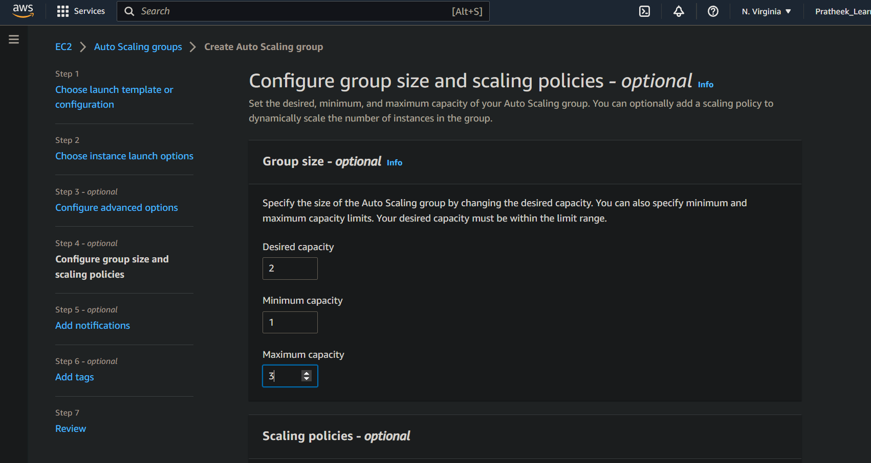

Step 4:- ASG created from Launch configuration

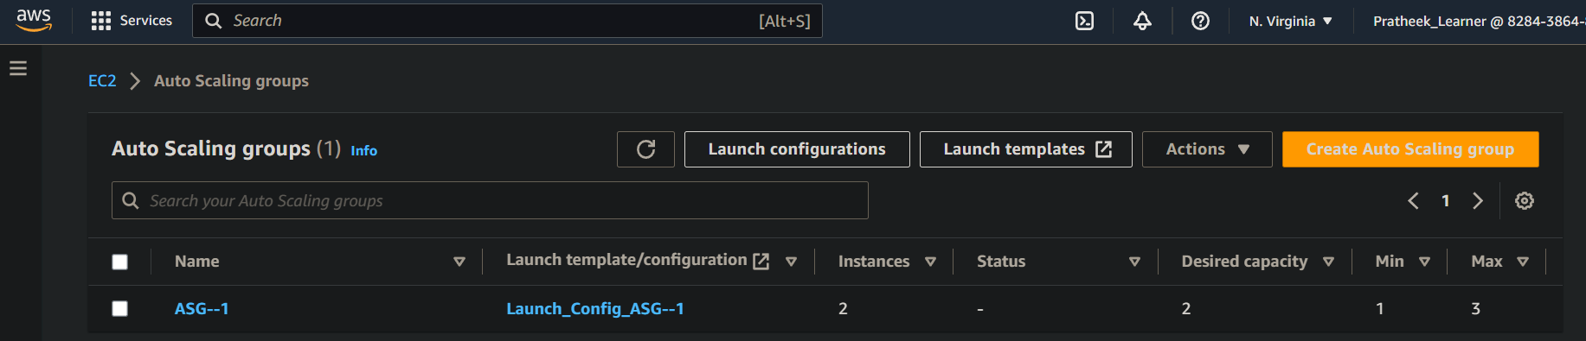

2 new instances created as per ASG desired value

